

What Our Clergy

are Saying





I pray for them;

I am not praying for the world

but for those you have given me,

because they belong to you:

All I have is yours

and all you have is mine,

and in them I am glorified.

I am not in the world any longer,

but they are in the world,

and I am coming to you.

Holy Father,

keep those you have given me true to your name,

so that they may be one like us.

John 17:9-11

**Introduction**

For the last 18 months our diocese has been involved in an extensive listening exercise. Every parish community has worked through a substantial questionnaire, almost 5,500 young people responded to an online survey specifically designed for them. 1,720 individuals from around the North East shared their views on our Church and its witness in the world. All of our deacons and priests were invited to respond to a letter from Fr Jim O’Keefe to share their views on ministry - past, present and future. There were 36 responses from among the 154 active and retired priests (23.4%) and 7 responses from the then 29 permanent deacons in our diocese representing 24.1% of them. This report provides a summary of their hopes, fears and aspirations.

**Responses to the Priests’ Survey**

The priests’ responses to the questionnaire were without exception marked by the expression of strong commitment to the Church and vocation and a deep spirituality. They are also very consistent in conveying a sense of the importance of relationships in the life of the priests. This was the biggest single theme we found, appearing in 24 of the 36 responses. When asked what encourages and sustains them in their ministry as a priest, one responds very simply ***the laity***and another ***our people****;* another mentions ***the respect and friendship of lay people***; another ***being encouraged by ordinary loving and life- giving people, mainly lay people and religious***; another ***the privilege of being invited and welcomed into folks’ confidences, hopes, fears, dreams; their sacred moments, celebrations, bereavements, families, their very lives*** and of ***the utter beauty and mystery of the People of God*.**

The importance of relationships with other priests (as well as of prayer and of family relationships) also emerges clearly from the responses. The friendship and support of other priests, ***sharing their ups and downs*** is mentioned frequently as part of what encourages and sustains priests in their ministry. The flip side of this is quite a strong strand of worry about the isolation of present and future priests - 8 expressed worry about diminished priestly collegiality: ***I don’t think any of my generation,*** writes one priest, ***ever expected to spend so much of our lives alone***.Another writes **that *we cannot afford to become isolated, orthodox eccentrics***. A third observes ***a declining strength in the brotherhood of the priesthood*** over the years. A number write about the importance of working together more, of having more opportunities for getting together and growing in friendship.

A recurring theme is a degree of demoralisation, frustration and anger because hopes for change in the Church have not been fulfilled. At least nine of the respondents write of frustrated hopes, mentioning, for instance, ***slowness and reluctance in implementing Vatican II,***or ***leadership that looks more backwards than forwards***, or a Church that seems to believe ***that She, alone of all other organisations, bodies, groups can be immutable in belief for ever*,** or again ***the reluctance in those who lead and manage the institutional church to take change seriously, to resource it and take risks***.

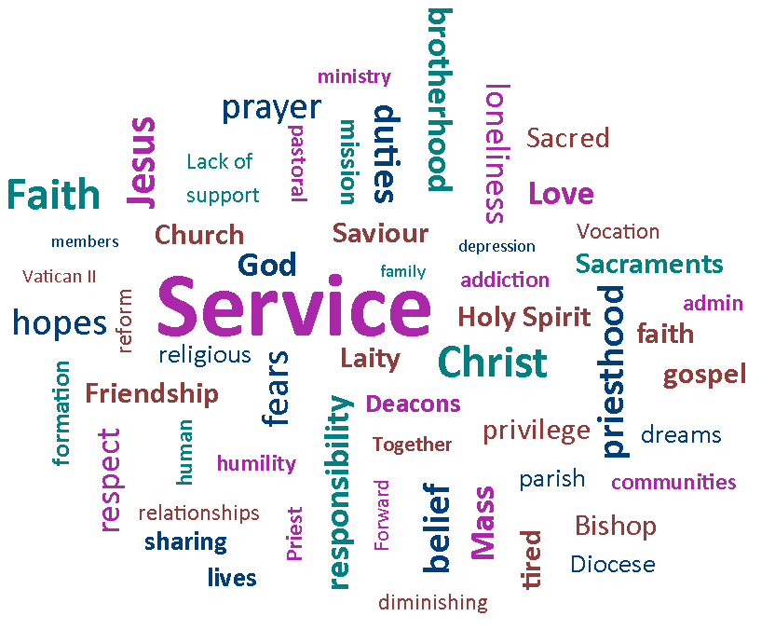

Although there is a very powerful sense of joy in the relationship to laity among the priests, there is also a motif of frustration with aspects of the clergy/laity relationship (in one way or another this is mentioned in 8 responses). One priest suggests we are in a transitional stage: before the priest-lay relationship was like a parent-child relationship, where the laity were to be seen but not heard; current laity are in an adolescent stage, sometimes wonderful and generous, at others inconsistent and unreasonable. Others voice frustration with ***people who can’t/don’t want to understand priests are human***, with unrealistic or contradictory expectations, with people who bring to sacramental programmes a consumer mentality, or have a ***‘Supermarket’ attitude to Church***, with congregations who respond passive/aggressively ***as we try to change and face challenges***.

The problem of overwork, or equally significantly, of being worked in the wrong way, comes through very strongly in the responses. 11 priests expressed concerns for their own future health - or even survival - and for that of other priests, if current patterns and trends continue. One priest warns that ***amongst us there are many mental health, addiction and spiritual issues****.* Another writes, ***I have 30 years of ministry to come before I reach 75. I am frightened that even if things continue with the current level of responsibility I will not see those 30 years***. Older priests express anxiety on behalf of younger. A retired priest speaks of his awareness ***of growing strain on ageing priests*** and another simply comments ***I’m glad I am retired!***Repeatedly the likelihood of burnout is mentioned.

Concretely, there are two things most discussed in connection with the issue of burnout. One is the burden of administrative and financial tasks, commented on in 13 of the responses. One priest writes that the increasing administration ***deadens me***, another comments that visiting parishioners - something he enjoyed - is a thing of the past, crowded out by administration. A few mention, in particular, the burden of sitting on school governing bodies. The second issue is the multiplication of sacramental duties, being expected to say multiple masses in multiple locations every weekend. One priest speaks of ***becoming a travelling sacramental machine*,** another of ***being a ‘Mass Machine’ and parish manager***.

There is a worry that priests will become ***clerical functionaries*** serving increasingly large clusters ***a bit like funeral directors***. One priest suggests at 50 he is already tired out by celebrating four masses across Saturday and Sunday, and writes: ***At the age of 65, I’m not prepared to be celebrating five or six Masses every Sunday* *because no one has taken any decisions****.* Overall there is a fear on the one hand that individual priests will not survive the demands of their role in the longer term, but will succumb to mental illness, burnout or death; and a sense on the other that many priests experience, and suffer from, at least a partial frustration of what they understand as their priestly vocation (there are indications of such a sense of the frustration of vocation in 10 of the responses).



**It’s a privilege being invited and welcomed into folks’ confidences, hopes, fears, dreams…**

What is to be done about the situation? Few of the respondents seemed to think themselves in possession of a blueprint for how the diocese should move forward. One says ***I haven’t a clue where to start***, and writes of the future as ***a dark fog***(though one that can be approached in faith, like the cloud of unknowing); another writes ***like so many others, I know that things cannot go on as they are, things need to change, but I have no idea what to suggest as a way forward. My ‘not knowing how best to proceed’ is maybe my greatest frustration of all*.**

There are, nevertheless, many affirmations of faith, frequent references to the importance of prayer and allowing the diocese to be led by God, and a range of concrete suggestions for the way forward. The single most consistent proposal in the priests’ responses is that lay leadership needs to be developed - this was mentioned, in one form or another, in 19 responses, while only 3 called for a greater focus on priestly vocation. ***We need***, writes one respondent,***to educate good laypeople, encourage them, listen to them and their views and priorities****.* Another suggests ***We priests need to step back, let them get on with it, and realise that there is more to priesthood than just keeping a good show on the road***. A third writes that evangelisation should be ***the top of every agenda*** but that ***we do not have enough time or capacity without empowering our laity***. Another writes that parish administrators should be trained and paid, that lay leaders of worship should be trained to undertake a wider range of duties, and that lay people should be trained and invested in to undertake outreach to the wider community.

One comment that captures the predominant tone of the responses is this: ***We are urgently in need of a robust lay formation programme* - *how long will this take to put in place*?**

Other suggestions vary. There are 6 who make positive reference to ordaining married priests. Some suggest ***concentrating resources on a network of vibrant parishes***. Some suggest the need for closures and selling off unneeded buildings. Some suggest lay led parishes, others the formation of small evangelising communities. Some suggest the importance of teams of leaders, of grouping parishes under the most dynamic priests, or of working with other church communities. Some suggest rethinking the commitment to Catholic schools, whose Catholic character is becoming increasingly difficult to maintain. A number suggest initiatives to support and renew priests, and enabling them to support one another. Some underline the importance of opportunities for study and for working in contexts other than the parish. Quite a number suggest the need to clarify and refocus the role of the priest, to bring it more in line with priests’ sense of their real vocation, and to strip away other kinds of tasks which priests have acquired.

Something which is marked in many of the responses is a real sense of urgency, of the need for something to be done, matched by a real fear that in fact nothing significant will be done. There are some positive responses to the *Forward Together in Hope* process, including appreciative comments on the parish gatherings it has involved, and the value of doing something other than ***manage decline***, but also some fairly sceptical reactions, including 5 respondents who indicate a form of consultation fatigue. One priest is ***sceptical that notice will be taken of what I say anyway*** and another writes ***I think it is too late******and I feel this exercise is just putting off the decision making... I will not hold my breath waiting for something to happen****.* One priest refers to ***the depression that hovers around the clergy (and much of the diocese) at this time***, two mention the moving of deckchairs on the Titanic, and a fourth expresses the fear ***that we won’t have the wisdom, humility and generosity to undertake reform. That we’re too old, too tired, too set in our ways to change***—but goes on to conclude ***all must be done prayerfully****.*

*‘…to use the skills and talents of lay people to maximum effect… to harness people’s professional skills for the benefit of the Church.’*

Some respondents see the current situation as a time of waiting for the new to emerge (one priest compares it to Jesus’ passion - ***We have to go through it, endure it, but with the hope that******something new is coming***) but more frequently there is a sense of urgency, of the need for active leadership, of the need for the ***diocese to make some radical and difficult choices****.* Alongside this is a fairly frequently voiced suspicion that what is urgently needed will not in fact be done (the fear that ***difficult decisions will be ducked or fudged***) and we will only be worse off (***If nothing changes after all this work we will have lost a lot of good will from the people***).

It should be said, finally, that it is hard to read these documents without coming away with a moving sense of the dedication, depth and commitment of the priests of the Diocese of Hexham and Newcastle.

**Responses to the Deacons’ Survey**

The broad picture emerging from the responses is that deacons feel supported by communities, by their families, by prayer, by their sense of their calling to serve people, and, on the whole, by priests. They view the diaconate as having a distinctive role of its own - they do not understand themselves as ‘***mini parish priests***’ or ‘***lieutenant priests***’. They are deeply committed to their ministry and find it rewarding.

One theme that occurs in several responses is a sense of the privilege of being allowed to share in people’s lives in their ministry: ***Pastoral care of the bereaved****,* writes one, ***is inherently spiritual and affords a Deacon the opportunity to be part of a family in grief, albeit for a short time. It is difficult to express this feeling***. For another it has***been a privilege to walk alongside people in their joy and pains, and to be welcomed into their lives with a great level of intimacy***.

Several speak of their work with the sick, including in hospitals, and of frustration at not being permitted to administer the Sacrament of the Sick.

While most of the deacons feel valued by their parish priest, there is also a certain sense of precariousness*.* Partly this is because ***support for deacons and a recognition of their ministry varies from priest to priest***; partly because, while the current Bishop is encouraging, the flourishing of their ministry in future will depend on his successors. Some deacons mention the need for improved communication, and observe that deacons are at times overlooked at diocesan level. For the future, there are a variety of suggestions: that deacons should be better distributed; that they should be more fully integrated into the pastoral care of their parish; that they should exercise their ministry also outside their parish, in their deanery or beyond (to help build wider communities). One issue on which deacons are united and which appears in most responses is the need for opportunities for peer support, for occasions, after formation, where they have contact with each other.

While the burden of the role does not (yet?) seem to weigh as heavily on deacons as on priests, one deacon outlines anxieties for the future which could serve as a pithy summary of difficulties highlighted in the priests’ survey: ***Fear of sheer exhaustion. Loneliness. Physical and mental wellbeing/health/lifestyle issues. Concern about an emphasis on ‘delivery of the Sacraments’ rather than space to build relationships and be part of people’s lives***. Several deacons also express concern specifically about the burdens on priests: ***I am often worried****,* writes one, ***about some of the priests I assist as I can see the toll their ministry takes***; another describes care for priests as ***less than acceptable****.*

Another deacon offers a wide-ranging critique of *Forward Together in Hope* and (what he takes to be) its likely outcome. Since this is the most extended and articulate critical response to *Forward Together in Hope* in either part of the clergy survey, it may be worth attending to with some care. The deacon suggests that the design of the parish questionnaires limits the possibility of change: ***Questions are answered through personal experience based against expectations already held. Such current expectations, derived from previous practice, experience and teaching in general, will mostly still form the basis of any new vision that may be brought forward*** - ***and can be very local and insular***.

He worries also that contemporary concepts of ‘problem solving’ will dominate the process, and that what in his view is the easier option of closing buildings and parishes - which ***effectively closes communities but makes the organisation simpler***- will be taken. He is concerned that ***we are trying to revive something (a system) which has had its day****.* He worries that if individuals prioritise ‘mass’ over ‘community,’ communities will diminish, never gather, and while ***great efforts******will be made to accommodate such circumstances*** the end result will be that ***the local needs of the community… are lost*** and ultimately ***the sick, lonely, bereaved, poor, …all will fall off the radar***.

As in the priests’ response, so also here, there is an emphasis on needing to strengthen the role of the laity, to ***use the skills and talents of lay people to maximum effect… to harness people’s professional skills for the benefit of the Church***. And as in the priests’ survey, there is in some of the deacons’ responses a sense of the urgency of the need for change and a worry that the *Forward Together in Hope* process will be too superficial. One writes of his frustration when ***we continually repeat behaviour/patterns that are ineffective***, and suggests: ***We need to look at the form of our communities and ask whether a model (parish) that …was designed when the world was at a different place is still the most effective form of community organisation. Instead of going larger perhaps we need to go smaller***.

Although there are fewer deacons than priests, and therefore the numbers of responses received has been small, the deacons clearly contribute a distinctive perspective to the process, one which partly overlaps with that of the priests but also enriches and broadens it.



**The Process and Acknowledgements**

The responses came in a variety of forms, sometimes as general letters to Fr Jim O’Keefe. A group was convened to discuss how they could best be processed (Jim O’Keefe, Karen Kilby, a Catholic theologian, Jocelyn Bryan, a pastoral theologian and Methodist lay preacher, and Mathew Guest, a sociologist of religion). The group agreed that because of the small numbers and the variety of styles of response, it would be inappropriate to attempt statistical analysis of individual questions. In the case of the priests’ questionnaire, however, it was decided to do an analysis of the frequency with which themes emerged across the whole of the questionnaires. The group agreed a set of categories for this thematic analysis, and coding was undertaken by Tony Sacco.

In the case of the deacons’ questionnaire, the number of responses is too small to make even this sort of statistical analysis sensible. The group agreed that a summary report should be written for each of the two sets of questionnaire responses, aiming to capture something of the range, tone and emphases of the views expressed. Inevitably not everything can be captured, and inevitably there is an element of subjectivity in the selection and organisation of material; the consideration of these responses by a group which includes lay and ordained, Catholic and non-Catholic can diminish but not remove this element of subjectivity. The summaries above were drafted by Karen Kilby before being considered by the group as a whole.

*I would like to add my grateful thanks to those named above for their sheer professionalism and dedication and the respect they have shown in helping to produce this very powerful reflection on what clergy of our diocese have said. I am sure that it will be a most valuable insight to help us in our search for the most honourable way forward for the future.*

**Jim O’Keefe**

Diocesan Development Director

The *Forward Together in Hope* team: Jim O’Keefe, Tony Sacco and Nancy Gash can be contacted on:

Telephone: (0191) 243 3304 E-mail: hope@diocesehn.org.uk

Diocese of Hexham and Newcastle, Department for Development and Renewal

Tel: (0191) 243 3304 E-mail: hope@diocesehn.org.uk Web: www.hope.rcdhn.org.uk

©Diocese of Hexham and Newcastle – June 2016

Also available in other formats





Diocese of Hexham and Newcastle, Department for Development and Renewal

Tel: (0191) 243 3304 E-mail: hope@diocesehn.org.uk Web: www.hope.rcdhn.org.uk

©Diocese of Hexham and Newcastle – June 2016

Also available in other formats

